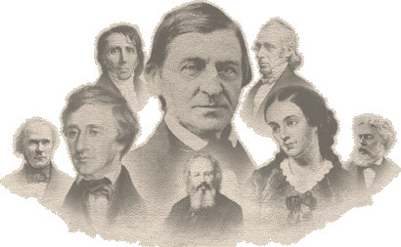
Transcendentalist Research Paper- Academic
You will choose from one of three Transcendentalist authors:
Ralph Waldo Emerson, Henry David Thoreau or Sarah Margaret Fuller or any other approved author.
Your assignment is to research your author by giving a brief biography, mentioning major literary works as well as their influence on the Transcendentalist movement.

Part I: Biography
This part focuses on how your author's life, friends, personal beliefs, and time period in which he lived influenced his writing. Research the author's childhood, life experiences, and the people who influenced him. You may choose to also explore the time period in which that author lived, and the social and literary movements that were taking place during his lifetime.
Part 2: Literary Works
This section focuses on what this author has accomplished in the literary world. What are some of he or she’s famous works and why are they so famous? Give a brief synopsis of at least ONE major work.
Part 3: Transcendentalist Movement
First, I would like you to briefly explain what the Transcendentalist Movement is. Give a brief overview. Why do you think your particular author is included in this movement?
Requirements:
MLA Format
2 pages
3 sources (properly cited) with a bibliography
Transcendentalist Research Paper- Honors
You will be assigned one of four Transcendentalist authors:
Ralph Waldo Emerson, Henry David Thoreau, Sarah Margaret Fuller or Walt Whitman
Your assignment is to research your author by giving a brief biography, mentioning major literary works as well as their influence on the Transcendentalist movement.

Part I: Biography
This part focuses on how your author's life, friends, personal beliefs, and time period in which he lived influenced his writing. Research the author's childhood, life experiences, and the people who influenced him. You may choose to also explore the time period in which that author lived, and the social and literary movements that were taking place during his lifetime.
Part 2: Literary Works
This section focuses on what this author has accomplished in the literary world. What are some of he or she’s famous works and why are they so famous? Give a brief synopsis of at least TWO major works.
Part 3: Transcendentalist Movement
First, I would like you to briefly explain what the Transcendentalist Movement is. Give a brief overview. Why do you think your particular author is included in this movement?
Requirements:
MLA Format
3 pages
4 sources (properly cited) with a bibliography

