APUSH Summer Assignment

While we want you to enjoy your summer, we also need you to understand the amount of work that goes into Advanced Placement United States History. This course will explore the history of the United States from 1491 to the present. It will strive to encourage students to practice history through the development of historical thinking skills while learning content as outlined in the AP US History Curriculum Framework created by the College Board. This will be achieved by exploration and interpretation of primary sources and secondary texts and through the regular development of historical argumentation in writing. The skills and content covered will prepare you to take the AP exam on May 10, 2019.

While every high school student in Pennsylvania must pass a US History course to graduate, enrolling in an Advanced Placement level course is an elective action. This class is extremely rigorous and will require a great deal of time and concentration on your part. If you are unwilling or unable to grant this course the time and effort required, you should consider choosing another level of US History to fulfill your graduation requirement.

Part One: In order to ensure that we can adequately cover the content prior to the exam, your first assignment is to read and outline the first two chapters of your textbook.
America’s History, 8th Edition. Henretta, et. al. Bedford Publishing, 2014.
Chapter 1: Colliding Worlds, 1450-1600
Chapter 2: American Experiments, 1518-1700
Get acquainted with the textbook. At the beginning of the chapter are “Big Idea” question to guide your reading and orange boxes with “margin questions” throughout the chapter that will help you to identify key points. Use the chapter review sections at the end of each chapter to focus on Key Concepts, Events, and use the Review Questions, Making Connections prompts, and timelines to help increase your understanding. It is our expectation that you will arrive on the first day of school with an outline in your hands (print it out if you type it).
For Chapter 1: You should start organizing information categorically to increase your understanding and help foster connections between material and aid you in writing historical argumentation essays. Please complete the attached “SPRITE” chart to the best of your ability in addition to your outline of the chapter.

Part Two: Ten Days that Unexpectedly Changed America by Steven Gillon
This book is written on some of the pivotal days that transformed the United States and will assist you in developing background knowledge for the APUSH course. Each chapter contains core APUSH themes that will be emphasized throughout the course.

Note to students:
The following pages include key vocabulary and discussion questions to assist you with the summer reading. As such, it is NOT a written assignment that must be turned in for credit. Instead, use this reading guide to check your comprehension and analysis of the content as you prepare for an assessment on the summer reading. You can expect that the assessment will happen within the first week of school. Each chapter has “Key Terms” and “Discussion Questions.” The key terms should aid you in answering the discussion questions and developing your understanding of the importance of the event.
Chapter 1 – Massacre at Mystic
Key Terms: William Bradford “Citty on the Hill” Massachusetts Bay Colony
Metacom Pequots Puritans
smallpox wampum John Winthrop

Discussion Questions:
- Why were the Pequots the focus of Puritan anger in the 1630s? (Why not other tribes? who was the opposition before/after the 1630s?)
- What were the Puritans’ justifications for conflict with Natives (hint: spiritual and secular)? Which was more influential on Puritan actions, and why?
- Gillon writes, “The Pequot War set up the tragic irony of American history: a nation founded on the highest ideals of individual liberty and freedom was built on slaughter and destruction of epic proportions.” (19) Assess the validity of this statement. (“Assess the validity” is a common phrase used in APUSH prompts. It’s asking you to judge the accuracy of the statement, which in this case is essentially an agree/disagree situation. Which side you take is less important than what sort of facts and reasoning you can provide to support your stance.)
- On page 25, Gillon claims that the colonial conflicts between Natives and Europeans became a model for how Americans would treat Native Americans across the continent as the wilderness became transformed into civilization. What other events/episodes/issues in American history also represent and support Gillon’s statements. (Feel free to provide examples beyond what Gillon provides in this chapter)

Chapter 2 – Shays’ Rebellion
Key Terms: Anti-Federalists democracy James Madison
Articles of Confederation Federalists Daniel Shays
post-war depression The Federalist

Discussion Questions:
- Which aspects (i.e., weaknesses) of the Articles of Confederation increased the chances of domestic protest?
- How was the American Revolution viewed differently by the supporters and the opponents of Shays’ Rebellion?
- Gillon writes, “Fear of government had shaped the creation of the Articles of Confederation; fear of democracy defined the discussion of the new constitution.” (p. 48) How did the U.S. become more conservative following Shays’ Rebellion? (What elements were built into the U.S. Constitution by the Founding Fathers to protect the fledgling democracy?)
- Explain the gap between the ideals of the revolution expressed in the Articles of Confederation and the realities of power enshrined in the Constitution.
- Should “Shaysites” be commemorated and/or memorialized today? What are the arguments for and against this?

Chapter 3 – The Gold Rush
Key Terms: John Sutter Oregon-California Trail Manifest Destiny Californios
“foreign miners’ tax” Wilmot Proviso Missouri Compromise Popular sovereignty
Kansas‐Nebraska Act Dred Scott Decision

Discussion Questions:
- How did the Gold Rush help fulfill the notions of Manifest Destiny?
- What were the similarities/differences of the social and cultural make-up of the West compared to the more established eastern U.S.?
- What were the environmental effects of the California Gold Rush? (short & long term)
- What were the political consequences of the Gold Rush in the 1850s? How did it accelerate the division of the nation?
- What were the long-term economic consequences of the Gold Rush? (hint: think about transportation, communication, industries, etc.)
- How did the discovery of gold transform the American Dream in contradiction to the Puritan and Jeffersonian notions of success?

Chapter 4 – The Battle of Antietam
Key Terms: 13th Amendment 14th Amendment 15th Amendment
border states total war war of attrition

Discussion Questions:
- What were the advantages and relative disadvantages of the Union and Confederacy in the Civil War?
- How did the nature of the Civil War change as a result of the ‘victory’ at Antietam?
- How did the Emancipation Proclamation transform the war into a struggle over the meaning of ‘freedom’? How was the issuance of the Proclamation related to the Battle of Antietam?
- What were the elements of the modern American nation which took shape as a result of the Union victory in the Civil War and how is the legacy of Antietam alive today in both South and North?

Chapter 5 – The Homestead Strike
Key Terms: Andrew Carnegie “ironclad” contract Grover Cleveland
Henry Clay Frick Pinkertons Scientific Management
Terence Powderly Second Industrial Revolution Haymarket Square Riot

Discussion Questions:
- How were workers in the late 19th century unified? How were they divided?
- What factors caused labor unions to gain power in the late 19th century? What factors caused them to lose power in this era?
- What was the main cause of the failure of the Homestead Strike?
- What were the opposing visions of the meaning of democracy articulated by American workers and industrial owners? How are these ‘visions’ of democracy similar to and different from those articulated by Daniel Shays and the Founding Fathers?
- Describe the relationship between big business and government. What was the effect on organized labor? How did this relationship influence the future of industry in America?
Chapter 6 – Murder at the Fair: The Assassination of President McKinley
Key Terms:
“bully pulpit” Mark Hanna William McKinley “good” and “bad” trusts
Teddy Roosevelt American Century Protective tariff Anarchism
Conservatism JP Morgan Laissez‐faire liberalism Progressive Movement
Alfred T. Mahan Northern Securities Case Conservation movement

Discussion Questions:
- What were the main differences between the “Progressives” (the broader political movement, encompassing Republicans and Democrats alike) and McKinley’s traditional priorities?
- Teddy Roosevelt’s “trust busting” was his way of preserving capitalism and discouraging radical ideologies in the U.S. Cite two specific examples of Roosevelt’s approach, and explain how each demonstrated his concept of the President as “a steward of the people.”
- In the early years of the nation, a strong federal government was considered a threat to the rights and freedoms of the “common man” (a vestige of the Revolutionary era). How did Teddy Roosevelt alter this view of government as it relates to the interests of the masses?
- In what ways did TR’s presidential leadership foreshadow the New Deal and the Great Society?
- What were the elements of Theodore Roosevelt’s leadership and politics which have made him the first truly ‘modern President “and one of the most popular and influential American Presidents? Does he deserve his place on Mt. Rushmore?
- Explain how both Republicans and Democrats in the modern era can embrace Theodore Roosevelt as the spokesman for their respective philosophies?

Chapter 7 – Scopes: The Battle Over America’s Soul
Key Terms: William Jennings Bryan ACLU Christian fundamentalism
Clarence Darrow H.L. Mencken televangelists
National culture Ku Klux Klan Prohibition/18th Amendment
Darwinism/ Theory of Evolution Cross of Gold Speech

Discussion Questions:
- How did mass media (radio, theater, newspapers, etc.) produce a national culture in the 1920s? What were the pros and cons of this?
- The 19th Amendment ensured women’s right to vote in 1920. What other developments in the 1920s helped create a “modern” – untraditional – image for women?
- What were the significant changes that appeared in American society in the 1920’s? What role did the automobile play in bringing about these changes in American society?
- In what ways did the 18th Amendment represent an effort to define and defend ‘traditional’ American values and what it means to be an American?
- What were the underlying suspicions of democracy which the Scopes Trial exposed? What did H.L. Mencken mean when he said that ‘Civilized life is not possible under democracy’?
- What elements of the arguments over the Constitution which Shays Rebellion first exposed were repeated in the debate over teaching evolution? Summarize both points of view.
- In what ways were the debates over evolution a repeat of the ongoing fault line in democracy between the struggle for the rights of the minority against majority rule?

Chapter 8 – Einstein’s Letter
Key Terms: “military-industrial complex” Leo Szilard Leslie Groves
Manhattan Project Harry Truman Cold war
Franklin D. Roosevelt J. Robert Oppenheimer

Discussion Questions:
- What was the purpose and content of the letter and how did it change the course of history both directly and indirectly?
- What were the primary arguments for and against the use of the atomic bomb?
- For decades before 1945, American foreign policy wavered between isolationism and assertive international action. As Gillon writes, that all changed as the U.S. was forced to “abandon its instinctive isolationism and assume the responsibilities of a global superpower.” (196) Explain this concept.
- The atomic bomb did more than initiate the Cold War. Identify political, economic, and social effects on the United States (domestically) during the atomic age.
- To what extent was Eisenhower right about the “military-industrial complex”? Has this threat disappeared now that the Cold War is over?

Chapter 9 – When America Was Rocked
Key Terms: Ed Sullivan Elvis Presley Emmitt Till
Kinsey Report Brown v Board of Education Elvis Generation
Dick Clark’s American Bandstand

Discussion Questions:
- How was the Cold War a contributing cause to the widespread social conformity of the 1950s?
- Gillon writes that Elvis Presley’s talent was insufficient to attain such popularity: “It was the synthesis of black blues and white country music, the mixing of a white face and poor black music, that made him so unique and so threatening.” Explain this statement.
- Why was it ironic that television would be such an important medium for the spread of rock ‘n’ roll in the 1950s?

Chapter 10 – Freedom Summer
Key Terms: CORE Lyndon B. Johnson ‘freedom riders’
SNCC literacy tests/poll taxes J. Edgar Hoover
Greensboro Boys ‘poll tax’ Robert Moses

Discussion Questions:
- What were the various methods which were used to keep African Americans disenfranchised in the South, especially in Mississippi?
- Explain why Mississippi was a particular challenge for Civil Rights reformers.
- How did political interests delay the implementation of desegregation?
- What were the combination of forces which began to undermine racial segregation in the South prior to Freedom Summer?
- In what ways did the murders of these young activists mark the dividing line between the hope and idealism of the Civil Rights Movement of the early 1960’s and the discord and dissent that followed; ‘the breeding ground for the social turmoil of the rest of the decade.’
- How does this dark episode in American history underscore the redemptive process of democracy?
Period 1: 1491-1607 (Ch. 1 and part of Ch. 2)
AP Terms: AP vocab: Ch. 1 Colliding Worlds, 1450-1600 (p.37)
Maize* facilitate Key Concepts and Events: Ch. 1 Vocab:
Irrigation* incorporated tribute Bering Land Bridge*
social diversification* divergent coopted decentralized polities
Great Basin* encroachments matriarchy amorphous
Great Plains* sovereignty animism Mesoamerica
Mississippi River Valley* foster patriarchy kin-based bands
Atlantic seaboard* subjugation primogeniture semisedentary
agricultural economy* Ch. 1 Key People: peasants bureaucratic state
hunter-gatherer economy* Hiawatha republic chiefdom
Northwest/California* Martin Luther civic humanism confederacy
Columbian Exchange* Mansa Musa Renaissance exacerbate
Feudalism* Vasco de Gama guilds Eastern Woodlands
Capitalism* Christopher Columbus* Christianity sachems
maritime technology* Hernan Cortes heresy diplomacy
joint-stock companies Moctezuma/Montezuma* Islam The Great Lakes
epidemic Pedro Alvares Cabral Crusades delineate
Spanish Empire predestination steppe
encomienda Protestant Reformation potlatch
plantation-based agriculture Counter-Reformation conscription
caste system trans-Saharan trade caravel
Reconquista cajole
Key Concept 1.1: As native populations migrated and settled across the vast expanse of North America over time, they developed distinct and increasingly complex societies by adapting to and transforming their diverse environments.I. Different native societies adapted to and transformed their environments through innovations in agriculture, resource use, and social structure.
A) The spread of maize cultivation from present-day Mexico northward into the present-day American Southwest and beyond supported economic development, settlement, advanced irrigation, and social diversification among societies.
B) Societies responded to the aridity of the Great Basin and the grasslands of the western Great Plains by developing largely mobile lifestyles.
C) In the Northeast, the Mississippi River Valley, and along the Atlantic seaboard some societies developed mixed agricultural and hunter-gatherer economies that favored the development of permanent villages.
D) Societies in the Northwest and present-day California supported themselves by hunting and gathering, and in some areas developed settled communities supported by the vast resources of the ocean.

Key Concept 1.2: Contact among Europeans, Native Americans, and Africans resulted in the Columbian Exchange and significant social, cultural, and political changes on both sides of the Atlantic Ocean.I. European expansion into the Western Hemisphere generated intense social, religious, political, and economic competition and changes within European societies.
A) European nations’ efforts to explore and conquer the New World stemmed from a search for new sources of wealth, economic and military competition, and a desire to spread Christianity.
B) The Columbian Exchange brought new crops to Europe from the Americas, stimulating European population growth, and new sources of mineral wealth, which facilitated the European shift from feudalism to capitalism.
C) Improvements in maritime technology and more organized methods for conducting international trade, such as joint-stock companies, helped drive changes to economies in Europe and the Americas.

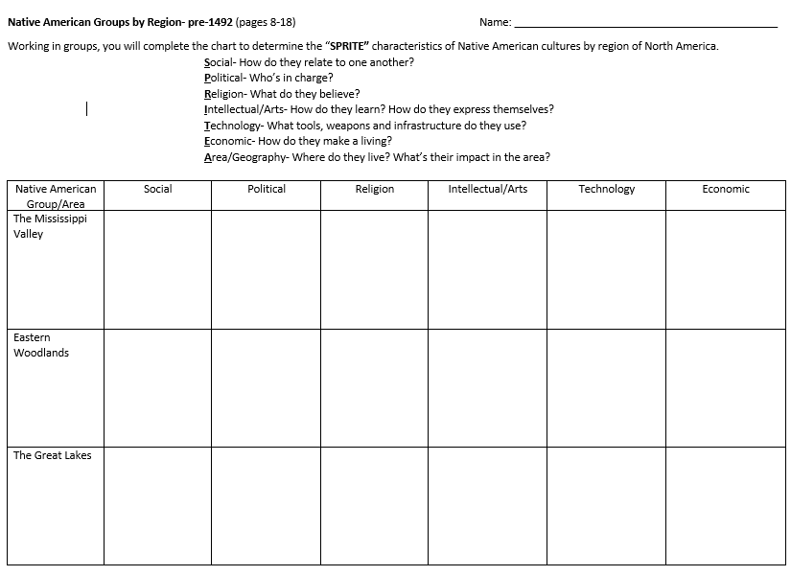
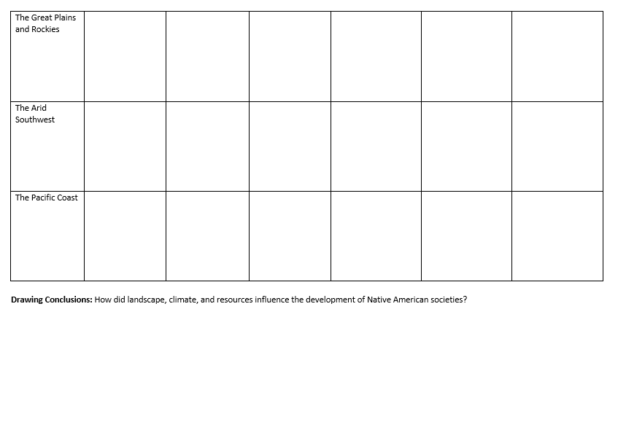Ch. 2- American Experiments 1521-1700 Time Period 2: 1607-1754 (Chs. 2 &3)
Key Concepts and Events: | Chapter Vocab: | AP Terms: | AP vocab:
chattel slavery* | obsolete | Colonization | imperial
neo-Europes | Caste/”casta” system* | Chesapeake & North Carolina | staple crops
Encomienda* | Yeoman | indentured servitude | democratic
Columbian Exchange* |  | New England colonies | epidemic
Jamestown |  |  | tobacco
Outwork |  | Puritans | pluralism
Mercantilism* |  | middle colonies | autonomous
House of Burgesses* |  | Atlantic Coast colonies | evangelicalism
Royal colony*/royal charter |  | British West Indies | The Enlightenment
freeholds |  | participatory town meetings | perpetuity
headright system |  | Atlantic economy
indentured servitude* |  | Metacom’s War (King Philip’s)
Pilgrims |  | Pueblo Revolt
Puritans |  | Anglicanization
joint-stock corporations* |  | mercantilism
predestination |  | chattel slavery
toleration
covenant of works
covenant of grace
town meeting
Key People:
Philip II
Francis Drake
Opechancanough
Powhatan
John Rolfe
John Smith
Lord Baltimore*
John Winthrop*
Roger Williams*
Anne Hutchinson*
Metacom (King Philip)*

Key Concept 1.2: Contact among Europeans, Native Americans, and Africans resulted in the Columbian Exchange and significant social, cultural, and political changes on both sides of the Atlantic Ocean.II. The Columbian Exchange and development of the Spanish Empire in the Western Hemisphere resulted in extensive demographic, economic, and social changes.
A) Spanish exploration and conquest of the Americas were accompanied and furthered by widespread deadly epidemics that devastated native populations and by the introduction of crops and animals not found in the Americas.
B) In the encomienda system, Spanish colonial economies marshaled Native American labor to support plantation-based agriculture and extract precious metals and other resources.
C) European traders partnered with some West African groups who practiced slavery to forcibly extract slave labor for the Americas. The Spanish imported enslaved Africans to labor in plantation agriculture and mining.
D) The Spanish developed a caste system that incorporated, and carefully defined the status of, the diverse population of Europeans, Africans, and Native Americans in their empire.
Key Concept 2.1: Europeans developed a variety of colonization and migration patterns, influenced by different imperial goals, cultures, and the varied North American environments where they settled, and they competed with each other and American Indians for resources
I. Spanish, French, Dutch, and British colonizers had different economic and imperial goals involving land and labor that shaped the social and political development of their colonies as well as their relationships with native populations.
A) Spanish efforts to extract wealth from the land led them to develop institutions based on subjugating native populations, converting them to Christianity, and incorporating them, along with enslaved and free Africans, into the Spanish colonial society.
B) French and Dutch colonial efforts involved relatively few Europeans and relied on trade alliances and intermarriage with American Indians to build economic and diplomatic relationships and acquire furs and other products for export to Europe.
C) English colonization efforts attracted a comparatively large number of male and female British migrants, as well as other European migrants, all of whom sought social mobility, economic prosperity, religious freedom, and improved living conditions. These colonists focused on agriculture and settled on land taken from Native Americans, from whom they lived separately.
II. In the 17th century, early British colonies developed along the Atlantic coast, with regional differences that reflected various environmental, economic, cultural, and demographic factors.
A) The Chesapeake and North Carolina colonies grew prosperous exporting tobacco — a labor-intensive product initially cultivated by white, mostly male indentured servants and later by enslaved Africans.
B) The New England colonies, initially settled by Puritans, developed around small towns with family farms and achieved a thriving mixed economy of agriculture and commerce.
C) The middle colonies supported a flourishing export economy based on cereal crops and attracted a broad range of European migrants, leading to societies with greater cultural, ethnic, and religious diversity and tolerance.
D) The colonies of the southernmost Atlantic coast and the British West Indies used long growing seasons to develop plantation economies based on exporting staple crops. They depended on the labor of enslaved Africans, who often constituted the majority of the population in these areas and developed their own forms of cultural and religious autonomy.
E) Distance and Britain’s initially lax attention led to the colonies creating self-governing institutions that were unusually democratic for the era. The New England colonies based power in participatory town meetings, which in turn elected members to their colonial legislatures; in the Southern colonies, elite planters exercised local authority and also dominated the elected assemblies.
III. Competition over resources between European rivals and American Indians encouraged industry and trade and led to conflict in the Americas.
A) An Atlantic economy developed in which goods, as well as enslaved Africans and American Indians, were exchanged between Europe, Africa, and the Americas through extensive trade networks. European colonial economies focused on acquiring, producing, and exporting commodities that were valued in Europe and gaining new sources of labor.
B) Continuing trade with Europeans increased the flow of goods in and out of American Indian communities, stimulating cultural and economic changes and spreading epidemic diseases that caused radical demographic shifts.
C) Interactions between European rivals and American Indian populations fostered both accommodation and conflict. French, Dutch, British, and Spanish colonies allied with and armed American Indian groups, who frequently sought alliances with Europeans against other Indian groups.
D) The goals and interests of European leaders and colonists at times diverged, leading to a growing mistrust on both sides of the Atlantic. Colonists, especially in British North America, expressed dissatisfaction over issues including territorial settlements, frontier defense, self-rule, and trade.
E) British conflicts with American Indians over land, resources, and political boundaries led to military confrontations, such as Metacom’s War (King Philip’s War) in New England.
F) American Indian resistance to Spanish colonizing efforts in North America, particularly after the Pueblo Revolt, led to Spanish accommodation of some aspects of American Indian culture in the Southwest.
Key Concept 2.2: The British colonies participated in political, social, cultural, and economic exchanges with Great Britain that encouraged both stronger bonds with Britain and resistance to Britain’s control.I. Transatlantic commercial, religious, philosophical, and political exchanges led residents of the British colonies to evolve in their political and cultural attitudes as they became increasingly tied to Britain and one another.
A) The presence of different European religious and ethnic groups contributed to a significant degree of pluralism and intellectual exchange, which were later enhanced by the first Great Awakening and the spread of European Enlightenment ideas.
B) The British colonies experienced a gradual Anglicization over time, developing autonomous political communities bsed on English models with influence from intercolonial commercial ties, the emergence of a trans-Atlantic print culture, and the spread of Protestant evangelicalism.
C) The British government increasingly attempted to incorporate its North American colonies into a coherent, hierarchical, and imperial structure in order to pursue mercantilist economic aims, but conflicts with colonists and American Indians led to erratic enforcement of imperial policies.
D) Colonists’ resistance to imperial control drew on local experiences of self-government, evolving ideas of liberty, the political thought of the Enlightenment, greater religious independence and diversity, and an ideology critical of perceived corruption in the imperial system.

