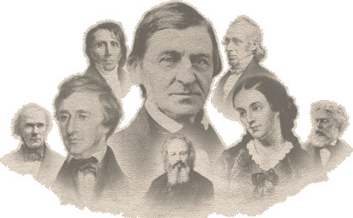
Transcendentalist Research Paper- Academic
You will choose from one of three Transcendentalist authors:
Ralph Waldo Emerson, Henry David Thoreau or Sarah Margaret Fuller or, any other author approved by me.
Your assignment is to research your author by giving a brief biography, mentioning major literary works as well as their influence on the Transcendentalist movement.
Part I: Biography
This part focuses on how your author's life, friends, personal beliefs, and the time period in which he/she lived influenced their writing. Research the author's childhood, life experiences, and the people who influenced them. You may also choose to explore the time period in which that author lived, and the social and literary movements that were taking place during his or her lifetime.
Part 2: Literary Works
This section focuses on what your chosen author accomplished in the literary world. What are some their famous works and why are they so famous? Give a brief synopsis of at least ONE major work. This does not need to be an entire novel. A chapter, poem, essay or another shorter work will be fine.
Part 3: Transcendentalist Movement
Start by briefly explaining what the Transcendentalism is; give a brief overview. Then transition into why you think your particular author has been included in this movement?
Requirements:
MLA Format
600 words
3 sources cited on a works cited page (a rubric will be given)

